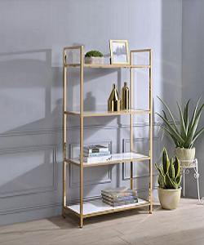

Simple unique Bookcase

$78.10

Availability: In stock

**Description:**

Simple wood bookcase with white base 4 sections. The real modular extruded wood bookcase,a special way to personalize your space.It's a system that can be used everywhere: in office, in living room,and in a book store of a winebar.This furniture is usable for every need.